Disease: Cercospora leaf spot

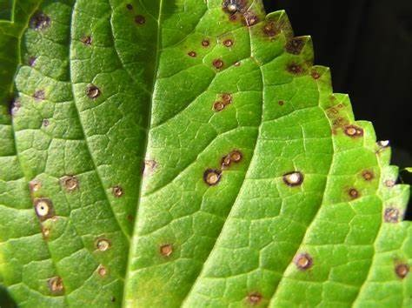Cercospora is a genus of ascomycete fungi. Most species have no known sexual stage, and when the sexual stage is identified, it is in the genus Mycosphaerella. Most species of this genus cause plant diseases, and form leaf spots. It is a relatively well-studied genus of fungus, but there are countless species not yet described, and there is still much to learn

about the best-known of the species.

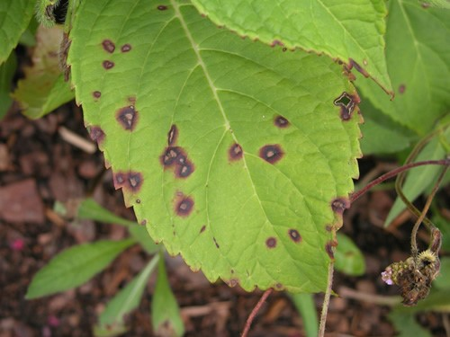**What causes cercospora leaf spot?**

Cercospora leaf spot can be caused by many different Cercospora fungal pathogen species

depending on the plant type infected. For example,

Cercospora beticola infects sugar beets whereas Cercospora rosicola infects rose plants.

**Treatment**

# Organic Treatment

Prune out the infection. Cut off infected foliage, twigs and branches and immediately gather the cuttings, along with any fallen limbs, leaves or other plant debris on the ground, and dispose of the material away from the garden. Do not compost the plant debris; burn the material, if local laws allow, to destroy the fungal spores. Disinfect pruning clippers and other gardening tools in between cuts and in between plants.

# Chemical Treatment

Fungicides generally are most effective at preventing rather than treating cercospora leaf spot on mulberry trees. The spray needs to be applied in early spring, right at bud break, and repeated at 10- to 14-day intervals. Check the label to be sure the fungicide controls cercospora and for application rates and instructions. Unless the tree is valuable, consider removing a severely infected mulberry tree and replacing it with a more resistant ornamental tree.